**Brief Intro**

Medico Pastoral Association (MPA) commenced in 1964 as the first and the oldest registered non-governmental organization to step into the then unexplored territory of rehabilitating mentally ill persons in India. It has, for over the past 50 years, continued to make strides in this realm. Apart from providing a surrogate home for individuals with disabilities arising from psychiatric illness, it also caters to many other needs of people with difficulties.

As early as 1964, much before any formal or conventional forms of intervention were introduced, a group of volunteers comprising professionals like doctors and clergymen under the Urban Industrial Mission Programme of St. Mark’s Cathedral, Bangalore got together to create awareness, and to provide training in skills required to remove the fear and misconceptions surrounding mental health problems. The movement initiated by these volunteers has been effective in the promotion of mental health and care of the mentally ill, and culminated in the formation of Medico Pastoral Association.

**History**

In 1964 that a small group of individuals including some doctors, social workers and clergymen concerned about the emotional and social well-being of individuals as well as the society at large in Bangalore came together under the Urban Industrial Mission of the St Mark’s Cathedral in Bangalore. Their concerns, efforts and activities steadily contributed to the birth of a secular and autonomous body, the non-governmental organization (NGO) in the field of adult mental health in India the Medico Pastoral Association (MPA).

Dr Joyce Siromani took the initiative in starting the Medico Pastoral Association (MPA) as its founding secretary. The Medico Pastoral Association was inaugurated in 1967 in St. Marks Parish Hall by Rt. Rev Norman Sergeant (Second Bishop of the Church of South India, Diocese of Mysore).

The association was registered under the Mysore Societies in 1972 (S.No.127/72-73 (03-08-1972). During the early years, the association continued to operate from the home of Joyce and Paul Siromani on the St. Marks's campus.

The idea for a Half-Way Home, the first of its kind in India was mooted by Joyce Siromani. The Half-Way-Home was planned to provide persons discharged from stand-alone psychiatric centres (mental hospitals) a period of stay in a therapeutic environment in a homely place, before returning to their own homes. It was felt that such a stay would help them to integrate better with their families/place of work/study.

Training of the first batch of suicide prevention volunteers – 1971

The Half Way Home was established in 1976 with 18 residents - nine women and nine men. Dr S S Jayaram, the National President of the Indian Psychiatric Society (IPS) in 1972, was the first Honorary Consultant Psychiatrist of MPA’s Half-Way-Home.

**1975 –** Built the firstHalf-Way Home in the country with love and dedication to help persons with mental disorder to regain social and living skills.

**1988** –First Hostel to look after recovered persons pursuing education and career goals

**1993 –** Mental Health Information Unit for networking and effective referral and guidance

**1997 –** Firstflexi-time period extended care for families who need respite

**1998** –First Home Care programme for behaviour management

**2000** – Modular training programme for skills in psycho-social education for care givers.

**2002** –First Suicide Prevention Helpline (SAHAI) in Bangalore, Karnataka

**Detailed Intro**

**Distinctive Features of Rehabilitation in MPA**

**Pioneer of psychosocial rehabilitation for persons with psychiatric disability**

MPA's decades of experience in providing psychosocial rehabilitation services for people with psychiatric disabilities have resulted in the distinction of being the first Half Way Home in India to have defined and set up trends through proven activities that facilitate rehabilitation, resocialization and recovery.

**Non-hierarchical setup**

The environment in the community is one that is positive and nurturing, with the presence of a rehab facility manager and caregivers. There is a cordial, friendly and respectful acceptance of the basic needs of security, self-worth and significance of each person entering MPA for psycho-social rehabilitation.

**Eclectic approach**

Recognizing the uniqueness of each person who comes in for rehabilitation from diverse cultural backgrounds and practices, the approach used is client-centred and eclectic. The flexibility of movement among facilities and programs is provided based on the functional abilities of each person with a psychiatric disability.

**Multidisciplinary treatment team**

The foundation for caregiving and support in MPA has evolved over the last four decades with the help received from varied sources. The treatment team consists of Therapists: Psychologists, Occupational Therapists, Social Workers, Counsellors and honorary Consultant Psychiatrists, Physicians and Nurse. Volunteers with special skills contribute as trainers for skills development and occupational therapy.

**Ethics**

The Community members and the staff are committed to:

* Upholding the traditions, values, dignity and worth, of each individual who comes to the rehabilitation centre for assistance.
* Ensuring high standards of professional conduct and competence.
* Maintaining strict confidentiality with respect to the personal data of the residents and any recipient of the Association's services.
* Establishing and maintaining appropriate professional relationship boundaries.
* Avoiding all forms of economic, emotional or sexual exploitation of residents or clients.
* Preventing discrimination against any individual owing to her/his social, economic and religious standing.
* Non-refusal of assistance to clients in need of services of MPA, and ensuring that clients are not abandoned or neglected in any form.
* Avoiding any kind of harassment, abusive words or actions and exploitative coercion.

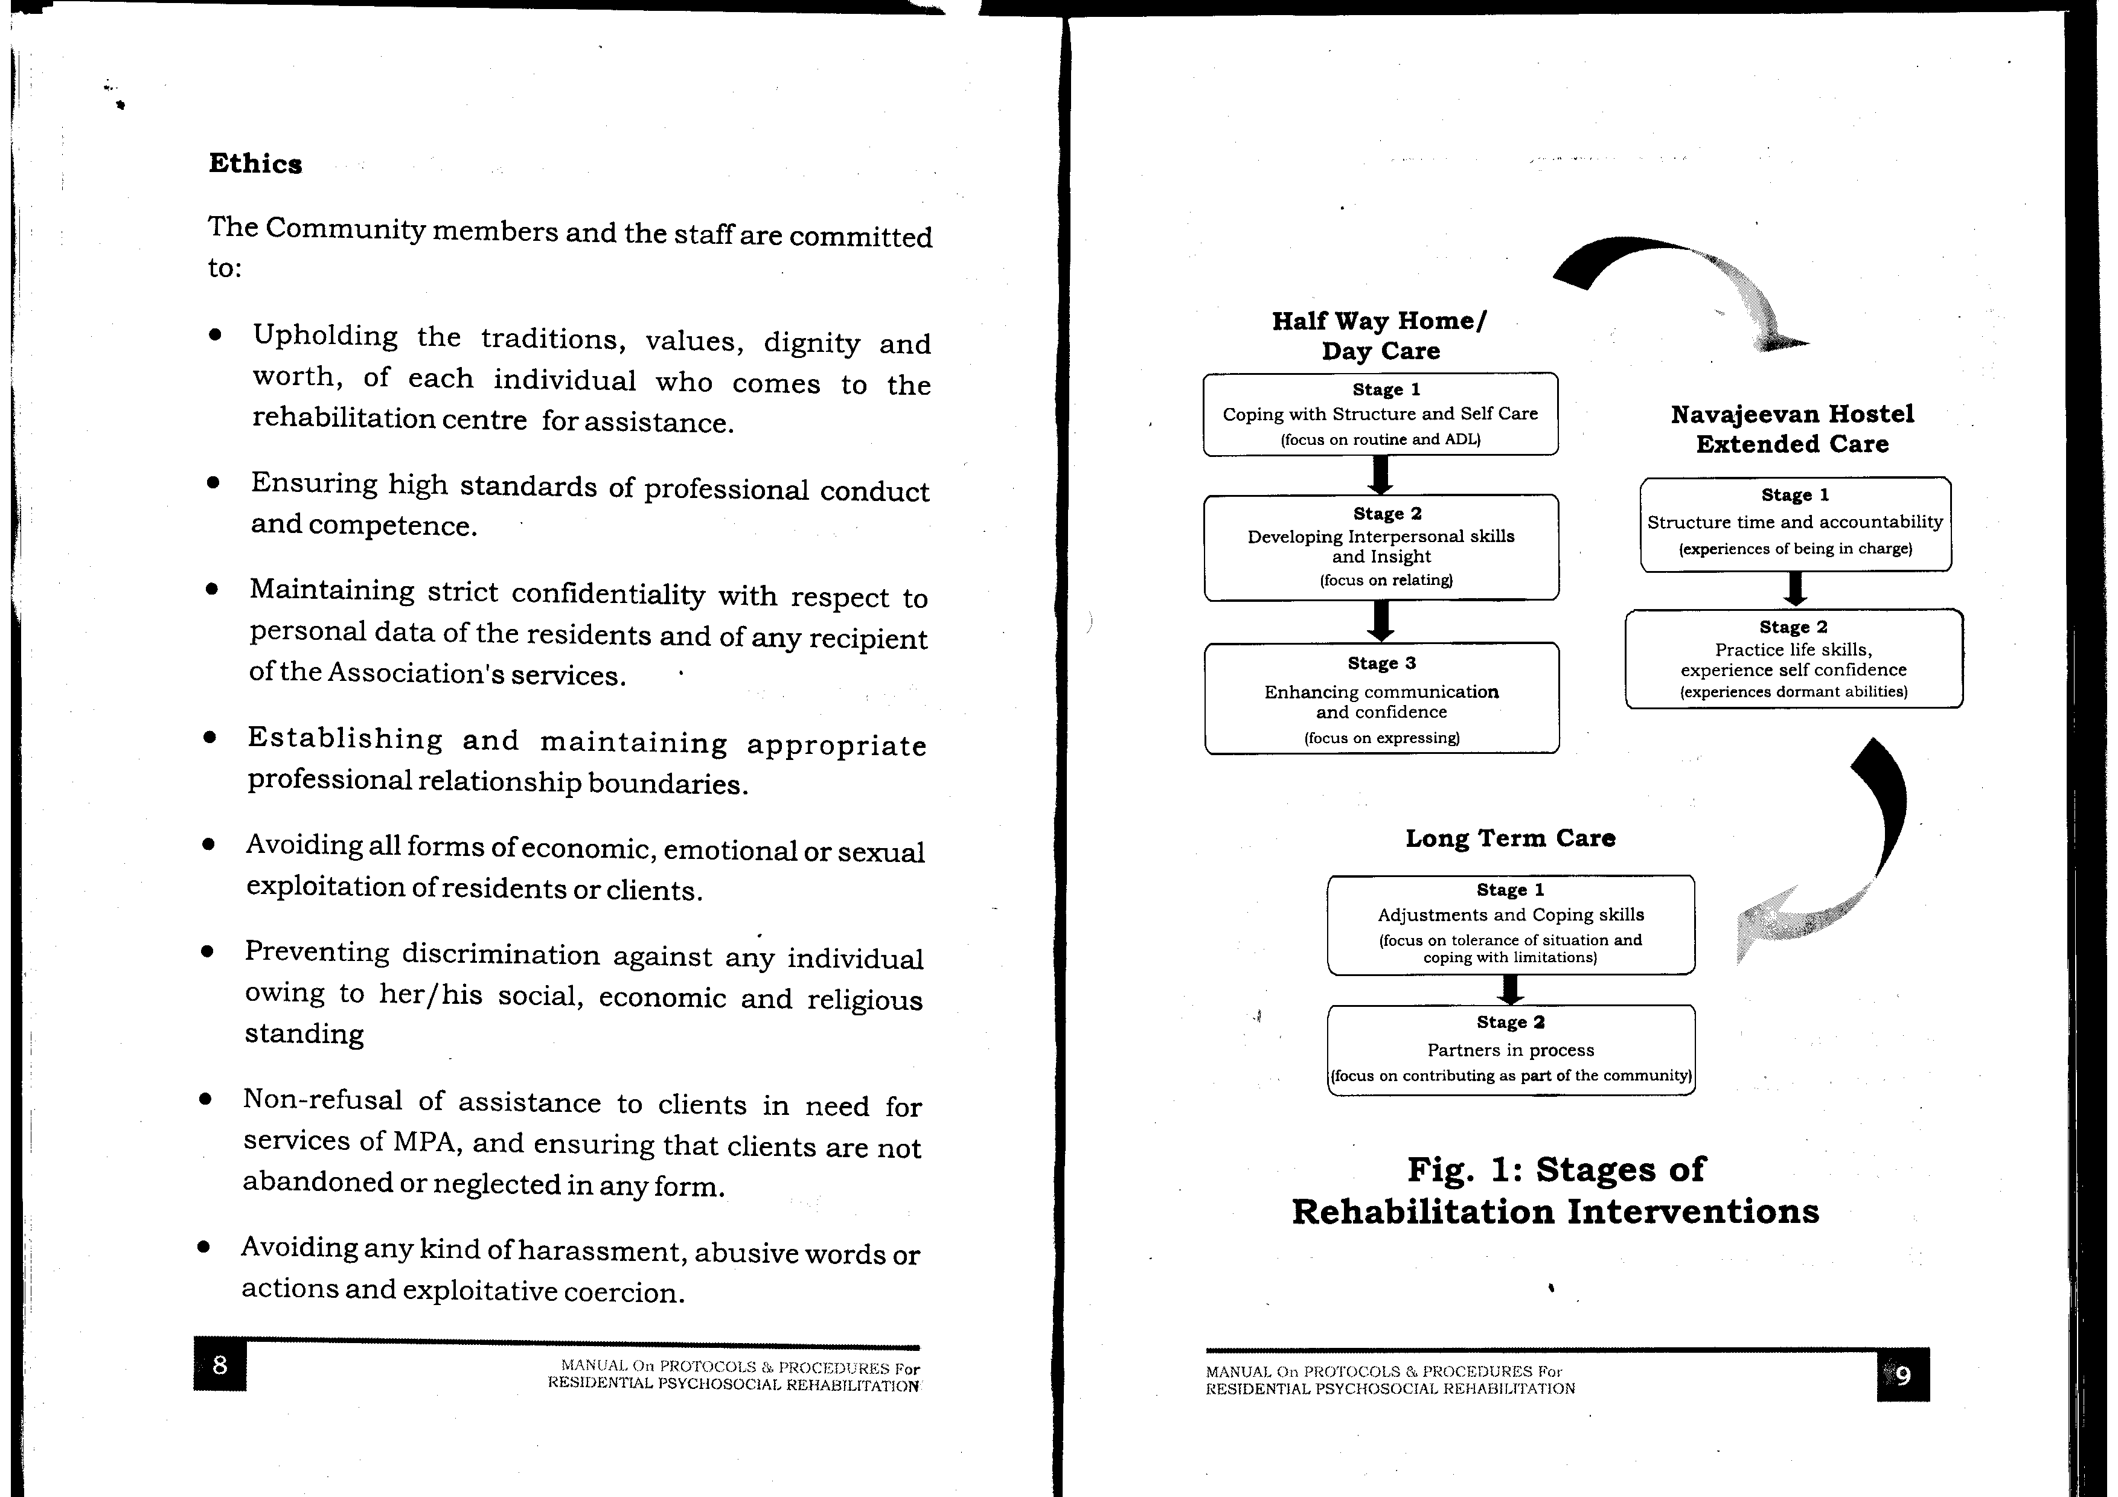

**Vision & Mission**

**Our Vision**

A holistic approach to mental health, improving the emotional and social wellbeing of individuals and society, focusing on the ‘Wholeness of Person’ and ‘Wholeness of Society’, and the challenges ahead.

We endeavour towards recovery-oriented rehabilitation aiming at full integration of persons with severe and chronic mental disorders into the mainstream. ‘Rehabilitation, Re socialization, Resettlement’ will continue to be the motto.

* To help caregivers to be empowered and supported with skills
* To empower our beneficiaries (those limited with disabilities arising from mental disorders) with social and vocational skills through a sheltered vocational training programme.
* To encourage our society to be sensitive to the needs of those who are limited with mental disorders and provide them with an opportunity to regain their self-worth.

**Our Mission**

* Meeting the objectives of the Association and accomplishing its mission to meet the needs of the whole man.
* Providing creative solutions in the management of psycho-social disabilities and professional interventions for persons with problems.

Addressing mental health issues in the community, promoting public awareness and reducing stigma.

**Our Milestones**

* 2014 - Long Supported Care Project launched!!
* 2007 - Cottages for Extended Care for Women
* 2005- Leased land purchased from BBMP and registered
* 2002 - Sahai Helpline for Suicide Prevention
* 2001 - Training Center & Staff Quarters (Alzira De Sousa)
* 1997 - Long Term Care for recovering men with mental disorders (Jeevanachaitra)
* 1988 - Extended Care Hostel (Navajeevan) for recovering persons with mental disorders
* 1975 - Got land on lease for 30 years from Bangalore City Corporation; First Half Way Home (Mana Shanti) was set up
* 1972 - Registration of Medico-Pastoral Association under Mysore Societies Registration Act 1960
* 1971 - Suicide Prevention Squad was formed
* 1969 - Alcoholics Anonymous was initiated at St Mark’s Cathedral by the MPA Volunteer Group
* 1964 - Counseling at St Mark’s Cathedral was initiated by the Urban Industrial Outreach Mission

**Contact Details**

#47, Pottery Road, Opp. Bangalore East Railway Station, Frazer Town,

Bangalore - 560005.

Ph: 25477375 / 25492934

[medicopastoralassociation@gmail.com](mailto:medicopastoralassociation@gmail.com)

[mpacounsellors@gmail.com](mailto:mpacounsellors@gmail.com)

**Facilities at MPA**

1. Half-way-Home (Manashanthi)

Half Way Home was set up in 1975 for both genders, between the ages of 18 to 55 years, in response to the increasing need for structured residential care. All residents of the Half Way Home are registered at hospitals with Psychiatric departments in Bangalore. Consultant Psychiatrists from the hospitals and in private practice in Bangalore.

The rehabilitation journey at MPA typically starts at the Half Way Home. Designed as a home away from home, it is a place for a person with a mental disorder who is at a recovery stage beyond that attained through psychiatric treatment, and is at a stage before he/she is ready to be welcomed into his/her own home. The focus here is on learning social skills and managing stress and feelings. The home accommodates both men and women.

1. Navajeevan Hostel for Men & Cottage for Women –

The Navajeevan Hostel & Extended Care was built in the year 1988 and Cottage Women was built in 2007 for those who recovered adequately from psychiatric illness but needed support to regain self-esteem and self-monitoring skills. The focus is to resume education, training or work life. After the resident completes the Half Way Home programme, the family or resident can request continued support for further training, work or educational needs.

3. Daycare

The Day Care Program for those not requesting residential needs was started in 1998. Facility for both men and women, who are recovering from mental illness. Rehabilitation work is carried out through therapeutic processes such as, Occupational Therapy, Individual Counselling, Group Activities, Yoga, Games & Sports, etc.

4. SAHAI - Suicide Prevention Helpline

SAHAI Suicide Prevention Helpline, run by the Medico-Pastoral Association was started in 2002. The inception of SAHAI was a tripartite collaboration between the Medico-Pastoral Association, the National Institute of Mental Health and Neurosciences (NIMHANS) and the Rotary Club Bangalore East. The SAHAI helpline was born in 2002. During those days, Dr Gururaj, the then head of the Department of Epidemiology at NIMHANS, was conducting awareness campaigns and awareness programs for preventing suicide across Karnataka state, especially in schools and colleges. Dr Gururaj had the plan of starting a helpline to prevent the suicides which were happening not only across the state but all across the country. And this idea was brought to the managing committee of MPA by Dr Mohan Isaac who was a colleague and friend of Dr Gururaj.  The helpline came into effect when MPA was ready to provide the location/space for the helpline at MPA premises. MPA was also glad to identify, train and provide volunteers to run the helpline. A team of psychiatrists from NIMHANS and many psychiatrist friends of MPA helped to train the volunteers. The rotary club provided the required finances to meet the expenses for the helpline during the initial years.

Today, at SAHAI Suicide Prevention Helpline, there are 22 trained volunteers as well as counsellors to address the calls from distressed. The volunteers belong to different backgrounds and a few of them are doctors, engineers, psychologists and others are housewives. The helpline, operational since 2002, works in three shifts from 10 am to 5.30 pm, having three slots, from 10 am to 12:30 pm, 12:30 pm to 3 pm and 3 pm to 5:30 pm. The helpline includes volunteers who are multilingual and can speak various languages such as Hindi, English, Kannada, Malayalam, Tamil, Telugu and Bengali. Over the years there have been periodical training programmes for new volunteers and refresher training for continuing volunteers to keep them updated in the field.

Contact No. 08025497777

5. Outside Counseling Services

**6. Students Internships**

Psychology, Social work, Journalism and Management students from colleges in Bangalore and outside the district or state do their fieldwork or block placement at MPA as part of their academic and practical training.

Activities involved in the supervision of the Internship students are:

1. Address all enquiries for the Internship politely and without delay
2. Categories of Internship:
   1. Fieldwork students
   2. Block placement
   3. Group orientation
3. Collect letters of referral from their School / College / Institute of study. Explore the report they are wishing to obtain from MPA.
4. Hold an orientation session, introducing the work of MPA
5. Provide each student, with the MPA evaluation form. Explain the points that need to be covered during the placement period.
6. Explain the organizational structure, the programs being held during their placement period, the community activities etc.
7. Give reading materials: newsletters, annual reports, published articles etc.
8. Collect the weekly reports. Correct any area of study/ data not understood. Invite questions.
9. Help make each student comfortable and more aware after their experience of being at MPA.
10. Students on placement are guided by the student supervisor in consultation with the Senior Counsellor and Clinical Manager.
11. Provide the certificate of attendance letter for the students signed by the Clinical Manager and Student Supervisor.

7. Orientation Visits

**Activities**

We have various Therapeutic Activities which include, training in ADL (Activities of Daily Living), Life Skills Development, Occupational Therapy, Art Therapy. Movement Therapy, Group Psychotherapy, Drama Therapy, Music Therapy, Individual Counselling, Family Counselling etc.

MPA's innovative facilities & services for the residential care and rehabilitation of the mentally ill and support to their families over the last 5 decades are well recognized and acknowledged by the community at large, not only in India but across the globe. MPA's community mental health activities especially in the area of raising awareness on Mental Health issues, and its Suicide Prevention Activities are also well recognized locally and nationally.

**Art Therapy**

Art is used as one of the mediums for facilitating emotional expression and non-verbal communication. The Therapists and Artists understand the concept of imagery and the therapeutic potentials of colour and texture

**Drama Therapy/ Psychodrama**

Drama as therapy or Psychodrama is primarily an action approach to group therapy. In Medico Pastoral Association (MPA) the Therapists facilitate the Residents to explore several themes related to daily living and relating skills through role-playing and enacting situations. The interaction involved in the psychodrama weaves imagination and physical action to discover creativity, develop behavioural skills and gain insight.

**Reel Therapy**

Reel Therapy or Movie Therapy is recently introduced in MPA. Movies affect many of us because of the images, music, dialogue, lighting, sound and special effects. Movies can provide catharsis; help with reflection and understanding of the lives of those around us and also help reflect on our own lives.

**Group Therapy**

Group therapy is a form of psychosocial therapy where a group of patients/ residents meet regularly to talk, interact, and discuss problems and life-enriching skills. Group therapy helps to bring relief when members share and discover that they are not alone.

**Occupational Therapy (O. T.)**

Occupational Therapy (OT) interventions at MPA focus on adapting to the environment, modifying the task, teaching the skill, and educating the resident/family to increase participation in and performance of daily activities for the residents. In MPA, residents are provided with the opportunity to gain or recover fine motor skills, improve attention and concentration span and build self-confidence and self-esteem through a variety of activities. The mediums used during O. T. for expression and learning, are currently Tailoring, Paper Bag Activity and Art & Crafts.

**Cookery Class**

Preparation of food is a life skill that all residents are provided with, as an opportunity to learn. Key techniques are taught so that each resident will be able to prepare their food from scratch, using fresh raw materials.

This activity is held weekly once with the help of Volunteer trainers or functional residents and supervised by the professional staff. Participation of the residents in the Cookery class is motivated by the incentive that they get to eat what they cook.

**MPA OLYMPIAD**

The MPA Olympiad has been designed to provide opportunities for every resident to participate in sports and games and receive recognition. The set of 60 games and activities is held over the span of four months annually. This is an event for promoting motivation.

**Counselling**

Counselling is a service offered to all the residents who are undergoing the psychosocial rehabilitation programme at the Medico Pastoral Association (MPA). The Professional team in MPA consists of Psychologists, Social Workers and Occupational Therapists. They are all called Therapists and having counselling skills is a prerequisite.

Counselling is always undertaken when the resident asks for it. An agreement/ contract is made on when the sessions will take place. Both individual and family counselling sessions are provided and the basic approach is person-centered.

Counselling by appointment is provided to external clients as part of the Community service.

**Outing & Programs**

**Movies**

For a person recovering from mental disorders, an outing for a movie provides the impetus and reason to dress up and experience a new environment. Going out for a movie also means having and handling some cash to snack out, and having a change from the usual rhythm of staying in a structured programme. This also allows them to experience mainstream society.

This activity takes place once every alternate month and helps to promote self-care skills, build visual analytical skills, interpersonal and social skills and money management.

**Meal-out**

Having a meal out is pleasurable for all the residents, as they get to choose the lunch they desire. It is also an opportunity to dress up and experience different tastes. This also allows them to experience mainstream society.

This activity is held on a weekday every alternate month when the residents of MPA are given a choice to choose what they wish to have for lunch.

**Picnic**

Once a year, a day is set apart for the residents to have a picnic outside the MPA premises with a view to sightseeing, to experiencing a longer length of travel and build bonds in an unstructured environment. For many who have experienced social exclusion because of the disorder, this is a new experience.

**Bangalore Rehabilitation Cricket League (BRCL)**

The Tennis Ball Knock-Out Cricket tournament, BRCL was initiated by the Medico Pastoral Association in 2010. This annual mainstream activity has been designed to provide competitive opportunities and promote motivation among residents and caregivers of psychosocial rehabilitation centers. This game is held once a year in collaboration with other psychosocial rehabilitation organizations in Bengaluru city.

**Internship for Students**

Psychology, Social work, Journalism and Management students from colleges in Bangalore and outside the district or state do their fieldwork or block placement at MPA as part of their academic and practical training.

Activities involved in the supervision of the Internship students are:

1. Address all enquiries for the Internship politely and without delay
2. Categories of Internship:
   1. Fieldwork students
   2. Block placement
   3. Group orientation
3. Collect letters of referral from their School / College / Institute of study. Explore the report they are wishing to obtain from MPA.
4. Hold an orientation session, introducing the work of MPA
5. Provide each student, with the MPA evaluation form. Explain the points that need to be covered during the placement period.
6. Explain the organizational structure, the programs being held during their placement period, the community activities etc.
7. Give reading materials: newsletters, annual reports, published articles etc.
8. Collect the weekly reports. Correct any area of study/ data not understood. Invite questions.
9. Help make each student comfortable and more aware after their experience of being at MPA.
10. Students on placement are guided by the student supervisor in consultation with the Senior Counsellor and Clinical Manager.
11. Provide the certificate of attendance letter for the students signed by the Clinical Manager and Student Supervisor.

**MANAGING COMMITTEE MEMBERS 2021-2022**

**Office Bearers**

1. Dr. Joseph George, President

2. Dr. Ajit Bhide, Vice-President

3. Mr. Samuel Mohan, Secretary

4. Mrs. Dipanjana Das Basu, Treasurer

**Members**

5. Mrs. Anita Gracias

6. Mrs. Thilaka Baskaran

7. Mr. Alphonse Kurian

8. Ms. Ellen Shinde

9. Dr. Joseph V. Philip

10. Mr. Biji G Koshy, Donor Member

11. Rev. Dr. Israel David, UTC, Institutional Member

**Nominated members**

12. Dr. Mohan Isaac

13. Dr. Mathew Varghese

14. Dr. Murali Thyloth

**Standing Committees**

**ESTABLISHMENT STANDING COMMITTEE**

1. Mr. Alphonse Kurian, Chairperson

2. Mr. Kesavan P.S

3. Mr. Madhan Gopal

**ACADEMIC, PUBLIC SERVICE & PUBLICATIONS STANDING COMMITTEE**

1. Mrs. Ellen Shinde (Chairperson)

2. Dr. Aarti Jagannathan

3. Mrs. Rohini Rajeev

**THERAPY & PROGRAMME STANDING COMMITTEE**

1. Dr. Mathew Varghese, Chairperson

2. Dr. T. Sivakumar

3. Dr. Joseph V Philip

**ADMISSION & DISCHARGE COMMITTEE**

1. Dr. Murali Thyloth  (Chairperson)
2. Dr. Virupaksha H.S
3. Dr. John P.John
4. Dr. Johnson Pradeep
5. Dr. Sundarnag Ganjekar